Practice Case 7

Business Acumen

Author: Nirta Ika Yunita

**Illy Café Business Case**

Andrea Illy is CEO of the global premium coffee company that bears his family’s name. As one might expect, he is passionate about coffee – its science, its health benefits, its taste, its beauty. Illy also has a dream that someday soon the coffee market might be transformed into something approaching the market for wine. Where connoisseurs discuss the fine points of various origin coffees and blends, where customers are willing to pay a premium for the finest examples of the coffee-making art, and where the growers, roasters and baristas will be compensated fairly for the expertise they contribute to every cup.

Unfortunately, the current coffee market differs from such an ideal. Coffee growers in most parts of the globe work at a barely subsistence level. One bad harvest (made all the more likely by the ravages of climate change) or a sudden decline in the commodity price of coffee can drop them below subsistence to hunger. Even in good times, growers have little incentive to improve their operation – they have minor contact with the roasters or customers and no knowledge of how their crops get translated into the cup. This disadvantages not only the grower but also the consumer – coffee sourced from good quality beans is hard to find.

Illy believes that the solution to the sad state of affairs is to initiate a “virtuous circle” that draws the grower, the roaster, the barista and customer together. Growers with better knowledge of the market will work to improve their crops or experiment with new varieties. Roasters and preparers will educate their customers as to the qualities of various beans, roasts and preparations. Customers, in turn, will be willing to pay more for the best beans and that premium will be sent back up the chain to pay for even more quality and variety. And so on.

Certainly there have been some positive signs. Indeed, many observers argued that a “third-wave” of transformation in the coffee market was already starting. (The first wave is said to have occurred when Maxwell House and Folgers made coffee a mass commodity, the second wave when Starbucks initiated a move to quality and higher prices.) Specialty coffee roasters had worked to build cafes and brands around origin-based beans sold directly to the roasters without reference to the commodity prices of coffee. With these third-wave roasters, every coffee came with a story of its origins and growers could count on occasionally eye-popping premiums for their beans.

As yet, specialty coffee represented a small sliver of the overall market and there were other signs that it might not ever grow beyond a small circle. New trends like coffee-based drinks and single-portion coffee in pods (e.g. K-cups, Nespresso) actually shifted more of the value-added towards roasters without a premium for growers. A consolidation was taking place among mass roasters that was even sweeping-up third-wave roasters in its wake. Observers argued that could lead to greater uniformity with even less emphasis on origin-based, direct-traded coffee.

Illy’s hope is that someone would come up with an innovation that would solidify the beginnings of the third wave and help reshape the market. Such a change would not necessarily have to involve illycaffè; Andrea Illy believes as the world’s premium brand, an increased emphasis on quality in the market would only help his company. The most important thing was to make the coffee supply chain more equitable and coffee better-tasting.

**1. What is the real problem this company facing? And how do you identify it?**

The real problem this company is facing is the coffee supply chain currently very not equitable. The coffee growers have minor contact with the roasters, baristas, and customers, so they have no knowledge how to make a good coffee that make good quality beans hard to find and the growers have a little incentive.

Customers have a little willingness to pay more for the best beans make it hard to produce better-tasting coffee.

The way to identify the problems is reading the highlighted parts.

**2. Which part of business components need improvement? Why?**

The business components part that need improvement are R&D, logistic, and marketing. The R&D team needs to develop high quality coffee that can compete with other competitors by research along with coffee growers so the coffee growers will also get knowledge how to produce high quality coffee beans. The logistic team needs to improve their supply chain management so there won’t be outdated coffee beans, less loss, and also less cost to produce high quality beans. Last but not least, marketing team is very important to educate customers about the brand and how coffee was made so that the customers willing to pay more for the best beans (better-tasting coffee).

**3. What kind of company transformation that might help the company to strife in the market?**

From what have been said for question number 2, we can make transformation such as; for the R&D, become a company that put forward the coffee quality. For logistic team, make a better supply chain management so that the quality of coffee produced stays high. The marketing team can make campaign to educate customer about the science, its health benefits, its taste, its beauty of drinking high specialty coffee so customers willing to pay more for a cup of good quality coffee. Therefore, coffee growers will have a better life and the company itself will gain high revenue.

**4. Propose an idea/ideas to create a new product**

Like others coffee company, they nowadays have mobile application to purchase their products so their customers have an easy access to purchase their product. I think, Illy Café needs to make a good one with better UI and UX.

For increasing customers’ experience, educate customers, and make them appreciate high quality coffee more, Illy Café can make coffee tour and class to experience a one-of-a-kind coffee journey from seed-to-cup like what Starbucks have done in their Dewata sanctuary outlet.

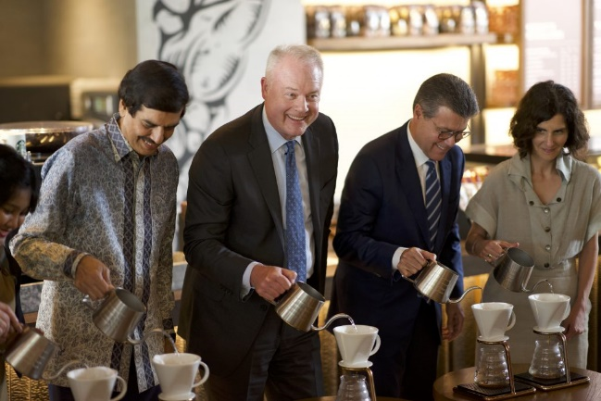

source: <https://swa.co.id/swa/trends/gerai-starbucks-dewata-coffee-sanctuary-terbesar-di-asia-tenggara>

With this kind of experience and education, it can make customers willing to pay more for the finest examples of the coffee-making art. All of these will affect to better coffee market where connoisseurs discuss the fine points of various origin coffees and blends and where the growers, roasters and baristas will be compensated fairly for the expertise they contribute to every cup of coffee.

**5. How do you propose the solution?**

To purpose the solution, to be on a mature market, to educate customers, to make growers, roasters, and baristas life better, to gain more profit, Illy Café needs a sustainable way of supply chain, make a good application to buy a cup of coffee, and make a coffee sanctuary. So, our product can be in the next level coffee, a better-tasting coffee.